Langcliffe Community Garden

Many of the houses in Langcliffe do not have gardens. Langcliffe Community Garden is a communal plot of land that enables village folk to grow things, whilst seeking to do more than that.

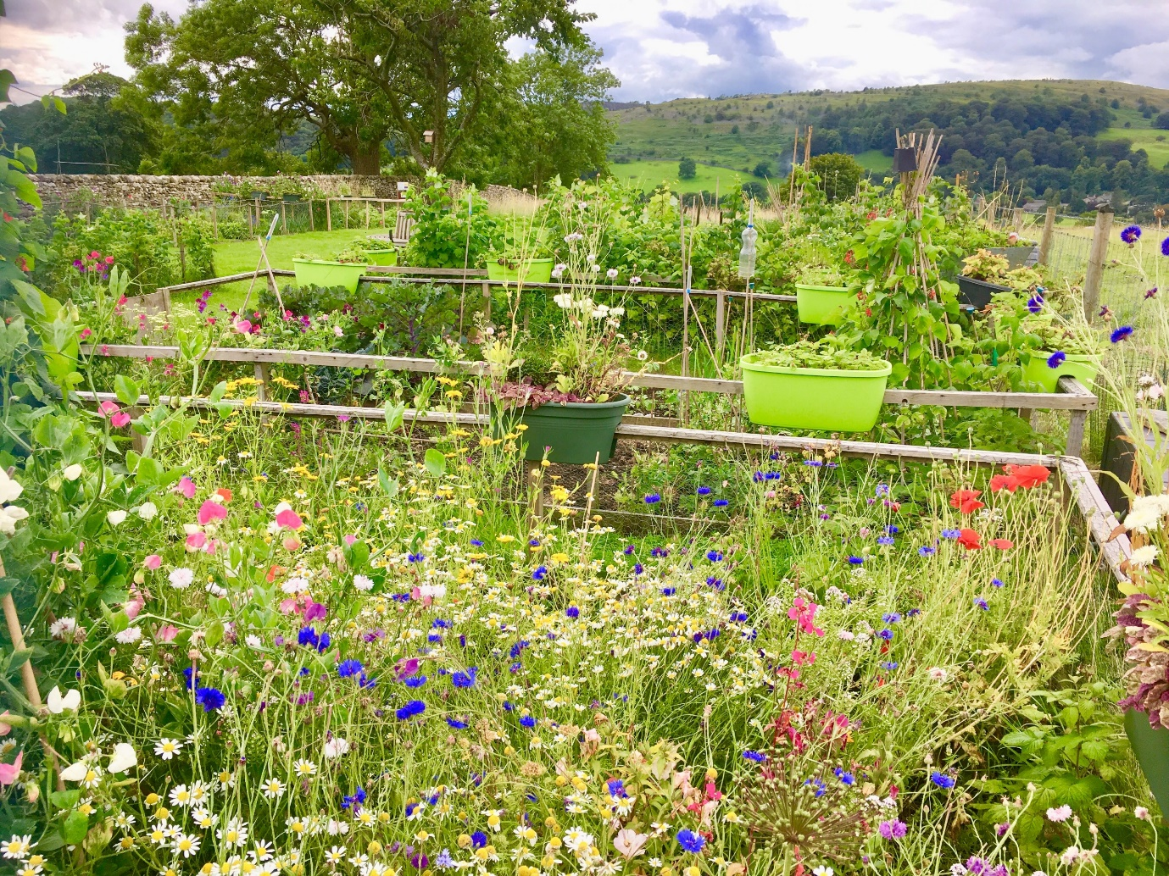
The garden is sited on the lane leading out of the village towards Winskill and Stainforth. The land is owned by a Trust in perpetuity for the benefit of those who live in the village.
The garden currently comprises 14 small growing plots. One of these is a communal plot, currently planted with a selection of herbs etc. for general use. Water is available on site.
The Woodland Trust provided over 100 saplings to the garden. Some of these were used as hedging, and others at the end of the garden to provide a windbreak in future years. Fruit trees provided partly by The Woodland Trust and partly by a number if village folk in memory of loved ones, have been planted for general enjoyment.
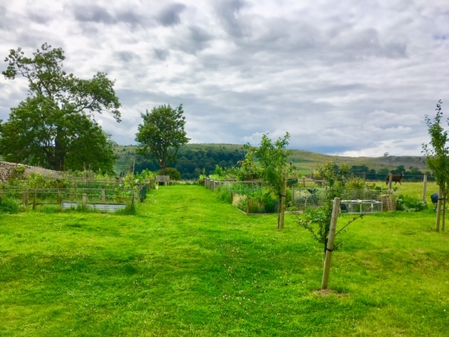

The garden seeks to encourage wildlife in all its forms. The Meadow Links project have advised on creating a wildflower meadow and donated seeds and plants. Several residents expressed an interest in keeping bees. Three hives have been located at the far end of the plot and all village residents are now encouraged to grow bee friendly plants. Care should be taken when approaching the hives. A wildlife pond is a project in progress at the planning stage.

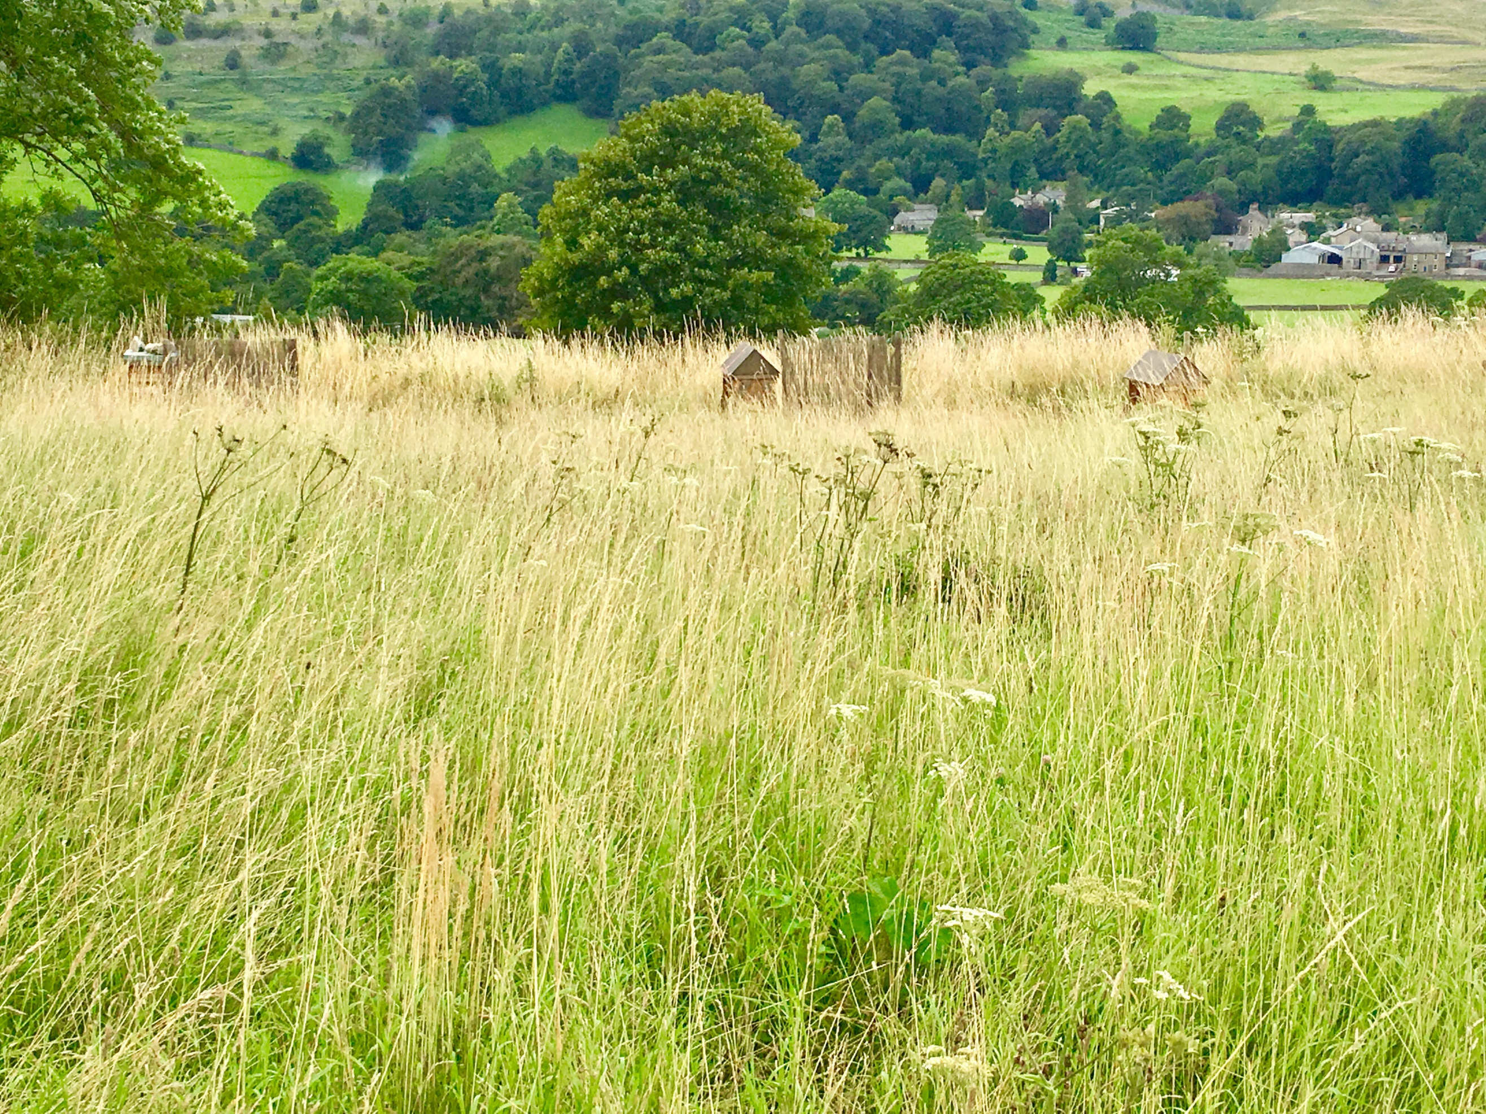
The Trustees are grateful to the following organisations for their support: -
The Woodland Trust
Meadow Links
Yorkshire Dales Millennium Trust
Roger Stott Community Grants Fund
The Craven Trust
Craven District Council Ward members
Becks Garden Machinery
