Christmas in Langcliffe.
A series of Village events mark Christmas in Langcliffe. In 2019 Father Christmas came at least twice to the village; once at the annual Christmas tree light switch on and again when the Settle Rotary elves brought him and his sleigh.
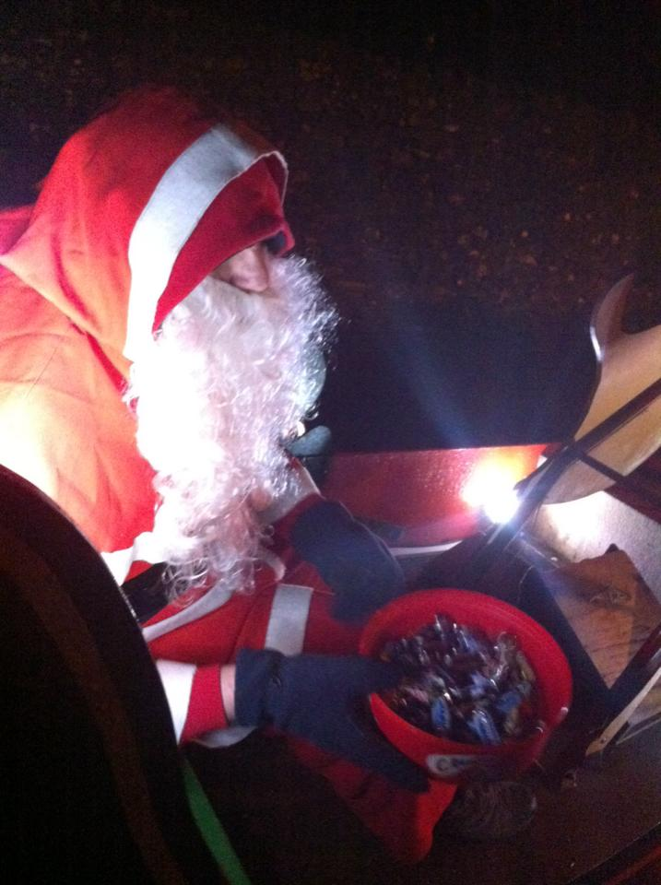

The annual Christmas Coffee Morning is always held in the Institute on the first Saturday in December. As well as raising funds for the Institute there are stalls for the Langcliffe Bees and the church.
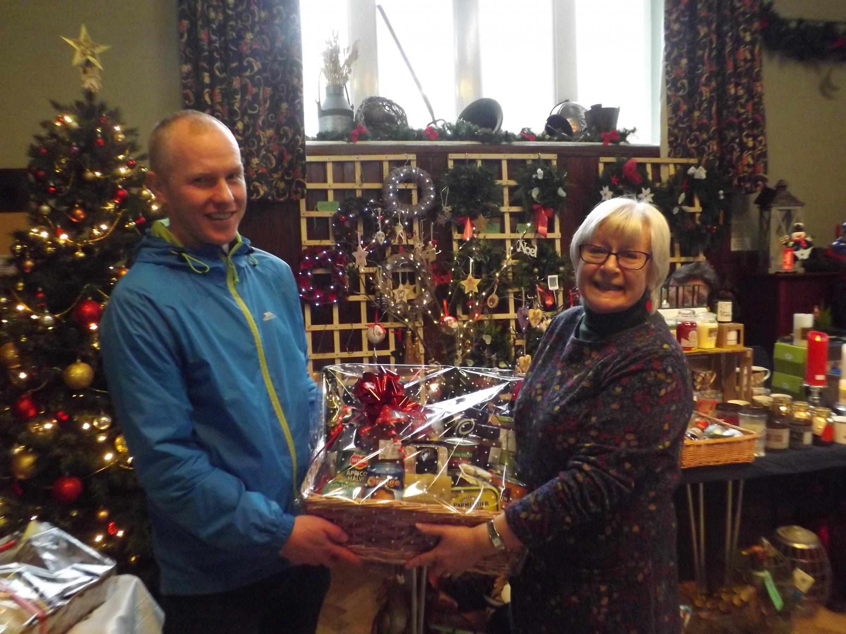
The village Christmas tree is funded by the Parish Council, erected and decorated by volunteers, after songs around it the big switch is thrown, and Father Christmas appears and gives presents to all the children. Afterwards people walk on to the Institute where mulled wine, hot soup and mince pies are available.
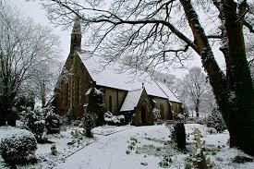

There is the usual singing carols around the village one December evening. There is also Christmas Eve get together followed by Midnight Service at Saint John the Evangelist’s Church.
Many villagers meet around the Village Tree at 9:30 on Christmas morning. Carols are sung, good wishes exchanges and everyone is invited to a local house to enjoy mulled wine and mince pies.
