Langcliffe Village Show.
The first Show was in 2012. Ian Johnson, and his late wife Barbara, returned to live in the village. They had both been involved in Giggleswick Village Show and had the skills to organise one here. Ian is still the Show Secretary. Lots of local people get involved. The classes have changed and developed over the seven years. Any money raised is distributed The Show has been in existence for eight years. between the church, the Community Garden with the Beekeepers and the Institute.
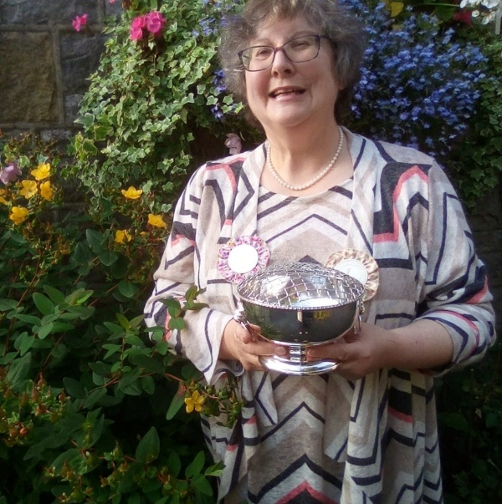
Helen Jarvis won the Reid James Silver Rose Bowl in 2019.
The Show is held on the third Thursday of August. The classes are; Children’s, Culinary, Preserves, Handicrafts, Produce, Flower Arrangements, Photography and Art.
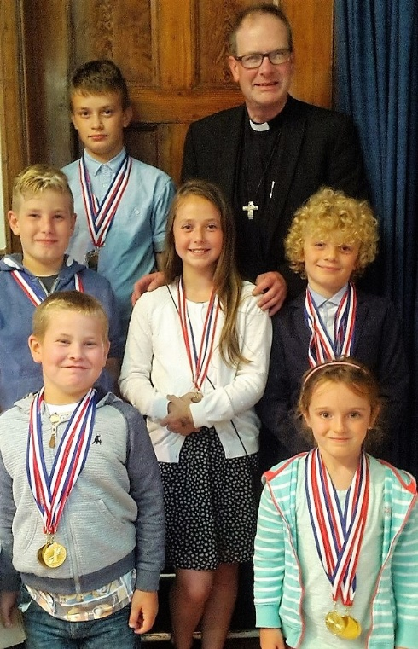
Medal winners in the Children’s Classes 2016.
Langcliffe is easily missed by people who do not realise this charming Victorian village lies just off the road to Stainforth. Resident, and Chairman of the Langcliffe Instute. Eric Parker explained. “There is a sign in Settle but there isn’t a prominent village sign to indicate the turn off. Parking is difficult as the village wasn’t designed for vehicles more sophisticated than the horse and cart. We do have a car park, situated just beyond the Institute, and there is parking along the main road. Visitors are asked not to park on the grass. It is pointless us raising funds to keep the village beautiful when visitors cause problems by thoughtless parking.”
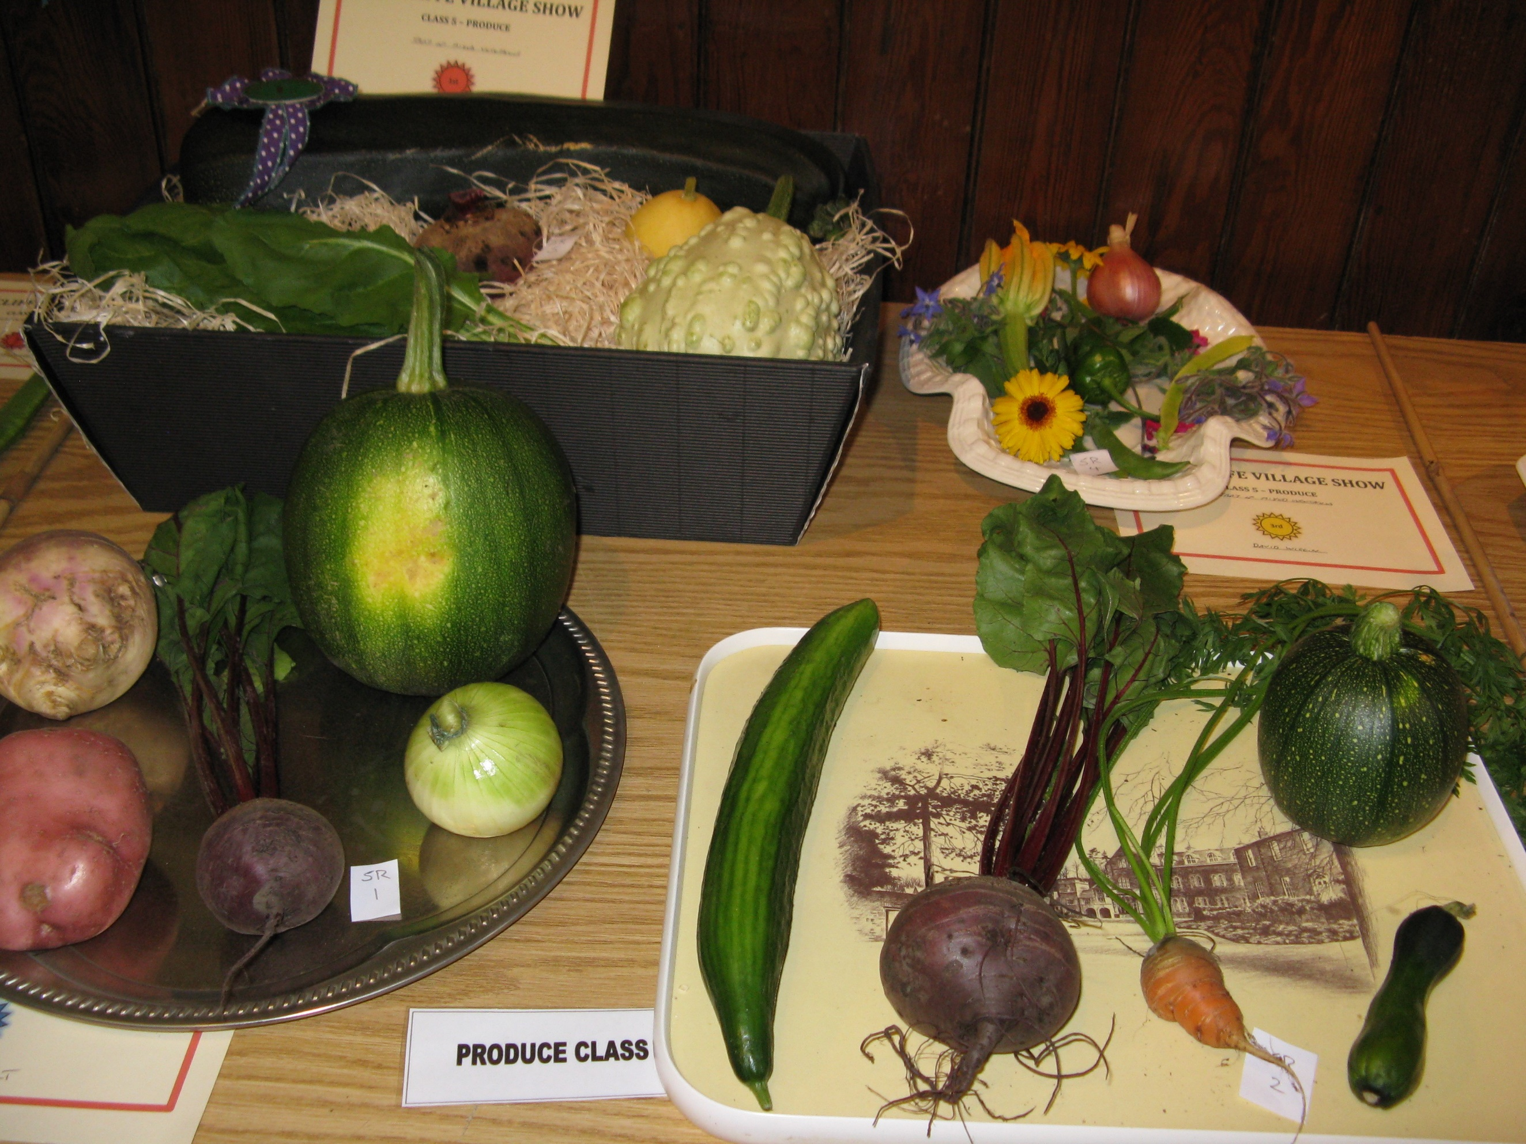
Eric, and a team made up from the Institute Committee, served refreshments throughout the Show afternoon raising £229 for the Institute.
The traditional after show ‘Pie and Pea’ supper served 68 villagers and friends. Thanks to Pat Smelt and her team for organising, cooking, serving and washing up after this. The meal was followed by an auction of donated exhibits. Eric Parker was the auctioneer and Alan Smelt the porter. This raised £131.90.
The raffle raised £139 and admissions £184.
There was an excellent turn out of exhibitors and visitors. The Show took place in the Village Hall and St. John’s Church. The categories and trophy winners were as follows;
Children’s Katy Hayes, Culinary Helen Jarvis, Handicrafts Averill Richards, Preserves Kate Croll, Produce David Croll, Photography Steven Lee, Flower Arrangements Averill Richards, Door Hanging Susie Lewis, Art Helen Jarvis/Pam Hicken. Judge’s trophies went to H Jarvis (x2), S, Woolley and J. Haines.
Helen Jarvis received the most points in show and was presented with the Reid James Rose bowl.
